DETERMINING MAXIMUM UNCERTAINTY IN GEOREFERENCED DATA

Use the Georeferencing Calculator (Wieczorek 2002)

http://www.manisnet.org/gc.html

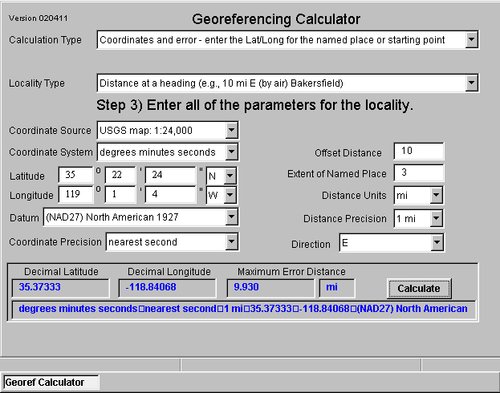

We are going to work through several examples in order to determine a value for the Maximum Uncertainty Distance.

Nombre de la localidad

Example 1
Locality: “Bakersfield”, USA.

Using your Web Browser

Go to http://www.manisnet.org/gc.html

For Calculation Type: use:
“Error – enter Lat/Long for the actual locality”
For Locality Type: use:
“Named place only”.

Coordinate System: degrees minutes seconds
Latitude: 35º 22' 24" N
Longitude: 119 º 1' 4" W
Datum: not recorded; 79 m uncertainty
Coordinate Precision: nearest second; 40 m uncertainty
Coordinate Source: gazetteer
Extent of Named Place: 3 km
Distance Units: km
Decimal Latitude: 35.37333
Decimal Longitude: -119.01778
Maximum Uncertainty Distance: 3.119 km

2. Desvío con distancia (Offset Distance)

Example 2
Locality: “5 mi from Bakersfield”, USA.

For Calculation Type: use:
“Error – enter Lat/Long for the actual locality”
For Locality Type: use:
“Distance only (e.g., 5 mi from Bakersfield)”.

Coordinate System: decimal degrees
Latitude: 35.373
Longitude: -119.018
Datum: NAD27; no uncertainty
Coordinate Precision: 0.001 degrees; 0.089 mi uncertainty
Coordinate Source: gazetteer
Extent of Named Place: 2 mi
Distance Units: mi
Decimal Latitude: 35.373
Decimal Longitude: -119.018
Maximum Uncertainty Distance: 8.089 mi

3. Desvío con dirección (Offset Direction)

Example 3
Locality: “W of Jondaryan, Queensland, Australia”.

For Calculation Type: use:
“Error – enter Lat/Long for the actual locality”
For Locality Type: use:
“Distance at a Heading”.

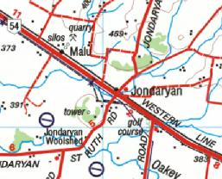

Coordinate System: degrees, minutes, seconds
Latitude: 27º 21’ 50”
Longitude: 151º 34’ 59”
Datum: AGD 84; no uncertainty
Coordinate Precision: 1 second
Coordinate Source: non-USGS map: 1:250,000; 0.16 km uncertainty.
Extent of Named Place: 0.8km (extent of Jondaryan)
Offset distance: 0.9 km (being one-half the distance between the western edge of Jondaryan township and midway to the Malu Railway Station).
Distance Units: km
Distance Precision: 1/10 km
Direction: W
Decimal Latitude: -27.36389
Decimal Longitude: 151.58306
Maximum Uncertainty Distance: 1.592 km

4. Desvío desde un punto inicial (Offset at a Heading)
Example 4
Locality: “10 mi ENE (by air) Bakersfield”
Suppose the coordinates for the locality were interpolated to the nearest second from the USGS Gosford 1:24,000 Quad map and the distance from the center of Bakersfield to the furthest city limit is 2 mi.

For Calculation Type: use:
“Error – enter Lat/Long for the actual locality”
For Locality Type: use:
“Distance at a Heading”.

Coordinate System: degrees, minutes, seconds
Latitude: 35º 24' 21" N
Longitude: 118º 51' 25”W
Datum: NAD27; no uncertainty
Coordinate Precision: nearest second; 0.024 mi uncertainty
Coordinate Source: USGS map: 1:24,000; 0.008 mi uncertainty
Offset Distance: 10 mi
Extent of Named Place: 2 mi.
Distance Units: mi
Distance Precision: 1 mi.
Direction Precision: 11.25 degrees either side of ENE
Decimal Latitude: 35.40583
Decimal Longitude: -118.85694
Maximum Uncertainty Distance: 3.772 mi

5. Desvío a lo largo de una ruta (Offset along a Path)
Example 5
Locality: “13 mi E (by road) Bakersfield”
Suppose the coordinates for this locality were interpolated to the nearest 1/10th minute from the USGS Taft 1:100,000 Quad map and the distance from the center of Bakersfield to the furthest city limit is 2 mi.

For Calculation Type: use:
“Error – enter Lat/Long for the actual locality”
For Locality Type: use:
“Distance along a Path”.
Coordinate System: degrees, minutes, seconds
Latitude: 35º 26 1’ N
Longitude: 118º 48.1’W
Datum: NAD27; no uncertainty
Coordinate Precision: 0.1 minutes; 0.148 mi uncertainty
Coordinate Source: USGS map: 1:100,000; 0.032 mi uncertainty
Extent of Named Place: 2 mi.
Distance Units: mi
Distance Precision: 1 mi.
Decimal Latitude: 35.43500
Decimal Longitude: -118.80167
Maximum Uncertainty Distance: 3.180 mi

6. Latitude and Longitude Coordinates
Example 6
Locality: “35 º 22' 24" N, 119º1' 4" W”

For Calculation Type: use:
“Error – enter Lat/Long for the actual locality”
For Locality Type: use:
“Coordinates Only”.

Coordinate System: degrees, minutes, seconds
Latitude: 35º 22’ 24” N
Longitude: 119º 1’ 4” W
Datum: not recorded; 79 m uncertainty
Coordinate Precision: nearest second; 40 m uncertainty
Coordinate Source: locality description
Distance Units: km, m, mi, yds, or ft
Distance Precision: 1 mi.
Decimal Latitude: 35.37333
Decimal Longitude: -119.01778
Maximum Uncertainty Distance: 0.119 km, 119 m, 0.074 mi, 130 yds, or 390 ft

Example 7
Locality: “35.37,-119.02, NAD27, USGS Gosford Quad 1:24000”

For Calculation Type: use:
“Error – enter Lat/Long for the actual locality”
For Locality Type: use:
“Coordinates Only”.

Coordinate System: degrees, minutes, seconds
Latitude: 35.27
Longitude: -119.02
Datum: NAD27; no uncertainty
Coordinate Precision: .01 degrees; 1434 m uncertainty
Coordinate Source: USGS map: 1:24,000; 12 m uncertainty
Distance Units: km, m, mi, yds, or ft
Distance Precision: 1 mi.
Decimal Latitude: 35.37
Decimal Longitude: -119.02
Maximum Uncertainty Distance: 1.446 km, 1446 m, 0.899 mi, 1582 yds, or 4745 ft

Wieczorek, J. 2002. Manual for Georeferencing Calculator. MaNIS/HerpNet/ORNIS. University of California, Berkeley: Museum of Vertebrate Zoology. http://manisnet.org/CoordCalcManual.html [Accessed 28 Jan. 2006].

