A Brief Tutorial on Maxent

By Steven Phillips, AT&T Research

This tutorial gives a basic introduction to use of the MaxEnt program for maximum entropy modelling of species’ geographic distributions, written by Steven Phillips, Miro Dudik and Rob Schapire, with support from AT&T Labs-Research, Princeton University, and the Center for Biodiversity and Conservation, American Museum of Natural History. The steps described here use the data from:

Steven J. Phillips, Robert P. Anderson, Robert E. Schapire.
Maximum entropy modeling of species geographic distributions.
Ecological Modelling, Vol 190/3-4 pp 231-259, 2006.

The environmental data consist of climatic and elevational data for South America, together with a potential vegetation layer. Our sample species will be Bradypus variegatus, the brown-throated three-toed sloth. This tutorial will assume that all the data files are located in the same directory as the maxent program files; otherwise you will need to use the path (e.g., c:\data\maxent\tutorial) in front of the file names used here.

Getting started

Downloading

The software consists of a jar file, maxent.jar, which can be used on any computer running Java version 1.4 or later. It can be downloaded, along with associated literature, from www.cs.princeton.edu/~schapire/maxent. If you are using Microsoft Windows (as we assume here), you should also download the file maxent.bat, and save it in the same directory as maxent.jar. The website has a file called “readme.txt”, which contains instructions for installing the program on your computer.

Firing up

If you are using Microsoft Windows, simply click on the file maxent.bat. Otherwise, enter "java -mx512m -jar maxent.jar" in a command shell (where "512" can be replaced by the megabytes of memory you want made available to the program). The following screen will appear:

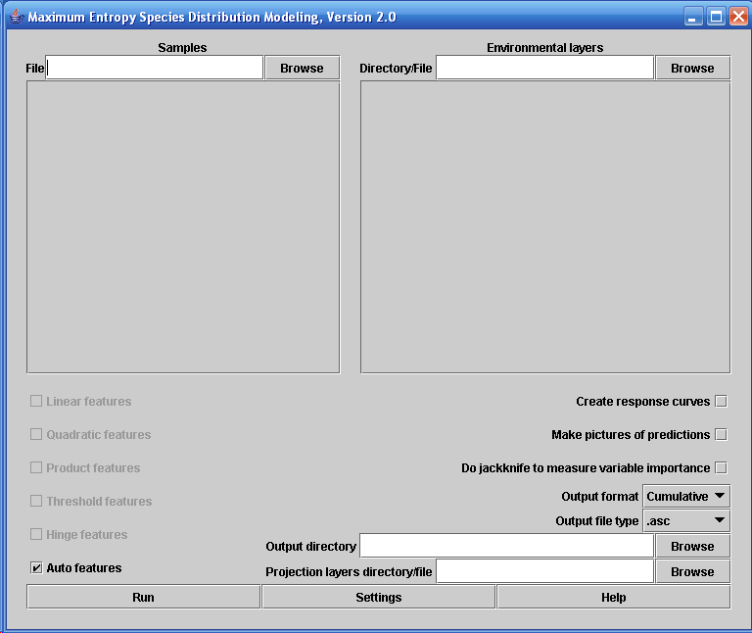

To perform a run, you need to supply a file containing presence localities (“samples”), a directory containing environmental variables, and an output directory. In our case, the presence localities are in the file “samples\bradypus.csv”, the environmental layers are in the directory “layers”, and the outputs are going to go in the directory “outputs”. You can enter these locations by hand, or browse for them. While browsing for the environmental variables, remember that you are looking for the directory that contains them – you don’t need to browse down to the files in the directory. After entering or browsing for the files for Bradypus, the program looks like this:

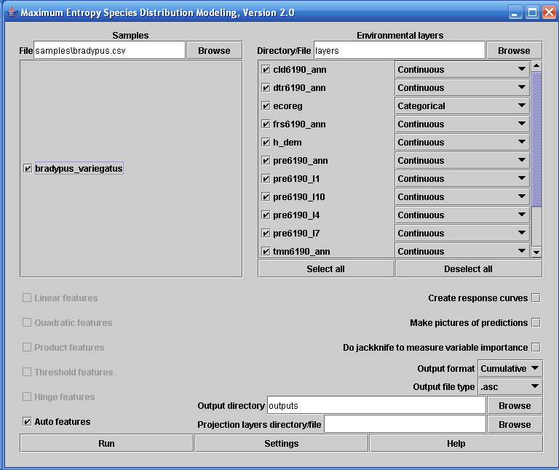

The file “samples\bradypus.csv” contains the presence localities in .csv format. The first few lines are as follows:

species,longitude,latitude
bradypus_variegatus,-65.4,-10.3833
bradypus_variegatus,-65.3833,-10.3833
bradypus_variegatus,-65.1333,-16.8
bradypus_variegatus,-63.6667,-17.45
bradypus_variegatus,-63.85,-17.4

There can be multiple species in the same samples file, in which case more species would appear in the panel, along with Bradypus. Other coordinate systems can be used, other than latitude and longitude, as long as the samples file and environmental layers use the same coordinate system. The “x” coordinate should come before the “y” coordinate in the samples file.

The directory “layers” contains a number of ascii raster grids (in ESRI’s .asc format), each of which describes an environmental variable. The grids must all have the same geographic bounds and cell size. One of our variables, “ecoreg”, is a categorical variable describing potential vegetation classes. You must tell the program which variables are categorical, as has been done in the picture above.

Doing a run

Simply press the “Run” button. A progress monitor describes the steps being taken. After the environmental layers are loaded and some initialization is done, progress towards training of the maxent model is shown like this:

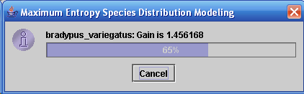

The “gain” starts at 0 and increases towards an asymptote during the run. Maxent is a maximum-likelihood method, and what it is generating is a probability distribution over pixels in the grid. Note that it isn’t calculating “probability of occurrence” – its probabilities are typically very small values, as they must sum to 1 over the whole grid. The gain is a measure of the likelihood of the samples; for example, if the gain is 2, it means that the average sample likelihood is exp(2) ≈ 7.4 times higher than that of a random background pixel. The uniform distribution has gain 0, so you can interpret the gain as representing how much better the distribution fits the sample points than the uniform distribution does. The gain is closely related to “deviance”, as used in statistics.

The run produces a number of output files, of which the most important is an html file called “bradypus.html”. Part of this file gives pointers to the other outputs, like this:

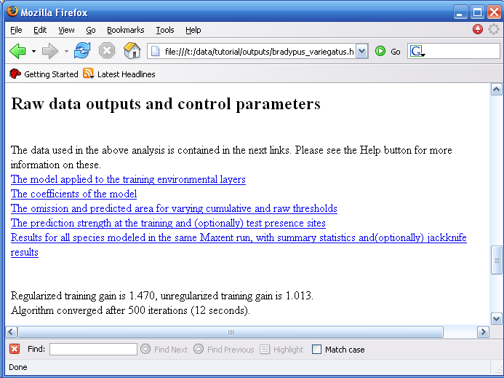
Looking at a prediction

To see what other (more interesting) content there can be in bradpus.html, we will turn on a couple of options and rerun the model. Press the “Make pictures of predictions” button, then click on “Settings”, and type “25” in the “Random test percentage” entry. Lastly, press the “Run” button again. After the run completes, the file bradypus.html contains this picture:

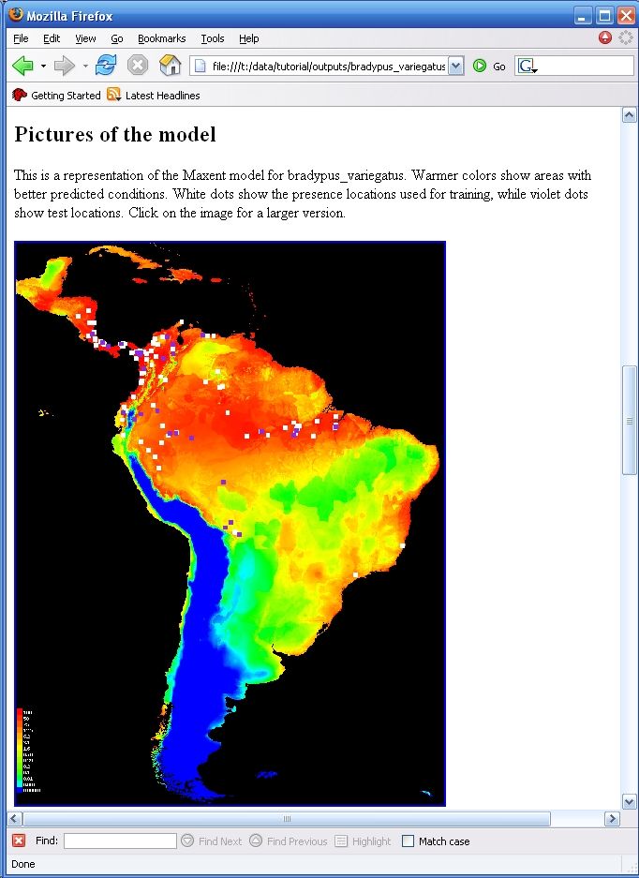
The image uses colors to show prediction strength, with red indicating strong prediction of suitable conditions for the species, yellow indicating weak prediction of suitable conditions, and blue indicating very unsuitable conditions. For Bradypus, we see strong prediction through most of lowland Central America, wet lowland areas of northwestern South America, the Amazon basin, Caribean islands, and much of the Atlantic forests in south-eastern Brazil. The file pointed to is an image file (.png) that you can just click on (in Windows) or open in most image processing software.

The test points are a random sample taken from the species presence localities. Test data can alternatively be provided in a separate file, by typing the name of a “Test sample file” in the Settings panel. The test sample file can have test localities for multiple species.

Statistical analysis

The “25” we entered for “random test percentage” told the program to randomly set aside 25% of the sample records for testing. This allows the program to do some simple statistical analysis. It plots (testing and training) omission against threshold, and predicted area against threshold, as well as the receiver operating curve show below. The area under the ROC curve (AUC) is shown here, and if test data are available, the standard error of the AUC on the test data is given later on in the web page.

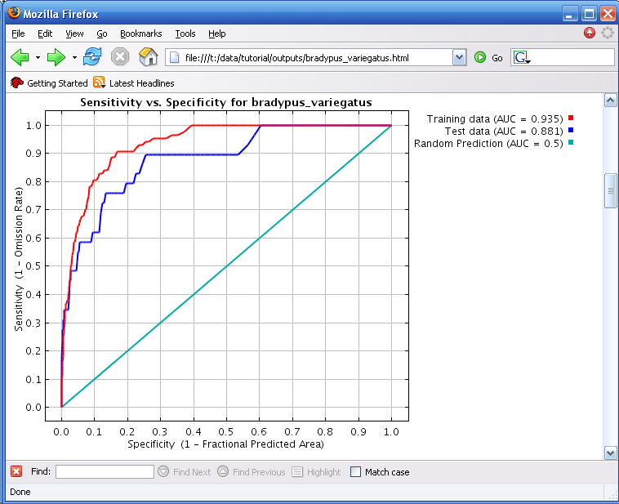

A second kind of statistical analysis that is automatically done if test data are available is a test of the statistical significance of the prediction, using a binomial test of omission. For Bradypus, this gives:

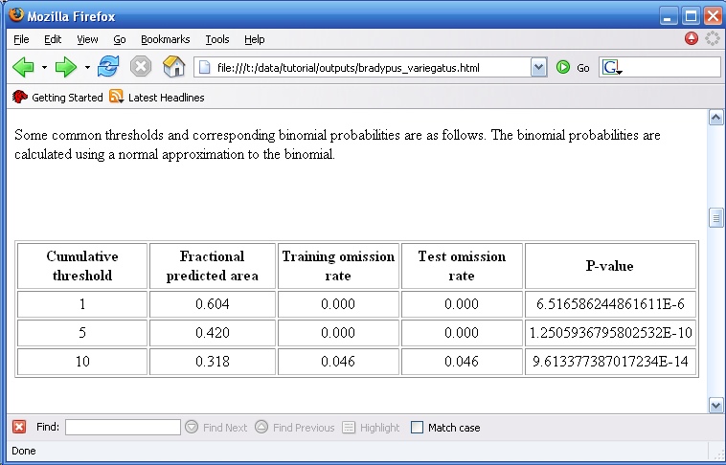

Which variables matter?

To get a sense of which variables are most important in the model, we can run a jackknife test, by selecting the “Do jackknife to measure variable important” checkbox . When we press the “Run” button again, a number of models get created. Each variable is excluded in turn, and a model created with the remaining variables. Then a model is created using each variable in isolation. In addition, a model is created using all variables, as before. The results of the jackknife appear in the “bradypus.html” files in three bar charts, and the first of these is shown below.

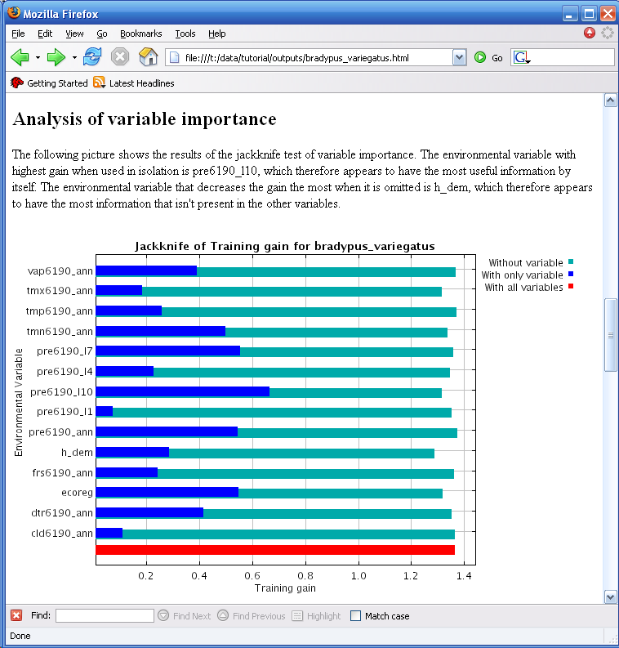

We see that if Maxent uses only pre6190_l1 (average January rainfall) it achieves almost no gain, so that variable is not (by itself) a good predictor of the distribution of Bradypus. On the other hand, October rainfall (pre6190_l10) is a much better predictor. Turning to the lighter blue bars, it appears that no variable has a lot of useful information that is not already contained in the others, as omitting each one in turn did not decrease the training gain much.

The bradypus.html file has two more jackknife plots, using test gain and AUC in place of training gain. This allows the importance of each variable to be measure both in terms of the model fit on training data, and its predictive ability on test data.

How does the prediction depend on the variables?

Now press the “Create response curves”, deselect the jackknife option, and rerun the model. This results in the following section being added to the “bradypus.html” file:

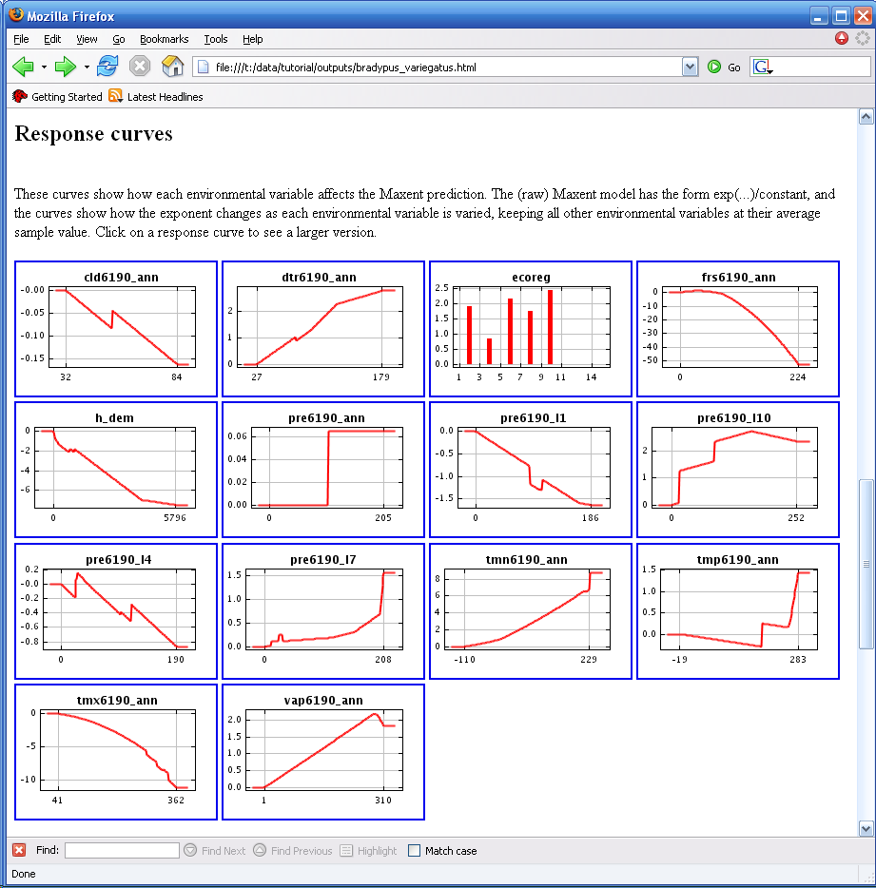

Each of the thumbnail images can be clicked on to get a more detailed plot. Looking at frs6190_ann, we see that the response is highest for frs6190_ann = 0, and is fairly high for values of frs6190_ann below about 75. Beyond that point, the response drops off sharply, reaching -50 at the top of the variable’s range.

So what do the values on the y-axis mean? The maxent model is an exponential model, which means that the probability assigned to a pixel is proportional to the exponential of some additive combination of the variables. The response curve above shows the contribution of frs6190_ann to the exponent. A difference of 50 in the exponent is huge, so the plot for frs6190_ann shows a very strong drop in predicted suitability for large values of the variable.

On a technical note, if we are modeling interactions between variables (by using product features) as we are for Bradypus here, then the response curve for one variable will depend on the settings of other variables. In this case, the response curves generated by the program have all other variables set to their mean on the set of presence localities.

Note also that if the environmental variables are correlated, as they are here, the response curves can be misleading. If two closely correlated variables have strong response curves that are near opposites of each other, then for most pixels, the combined effect of the two variables may be small. To see how the response curve depends on the other variables in use, try comparing the above picture with the response curve obtained when using only frs6190_ann in the model (by deselecting all other variables).

Feature types and response curves

Response curves allow us to see the difference between different feature types. Deselect the “auto features”, select “Threshold features”, and press the “Run” button again. Take a look at the resulting feature profiles – you’ll notice that they are all step functions, like this one for pre6190_l10:

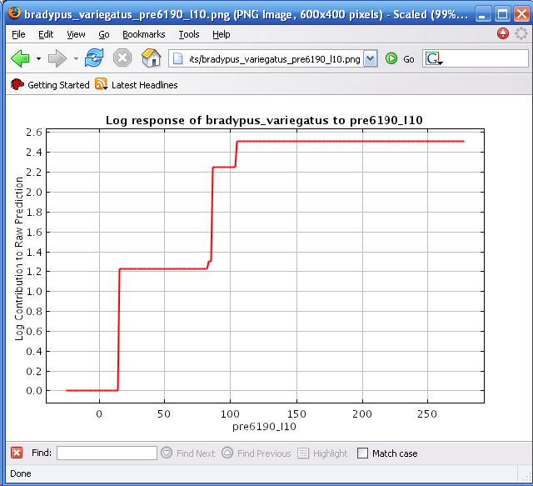
If the same run is done using only hinge features, the resulting feature profile looks like this:

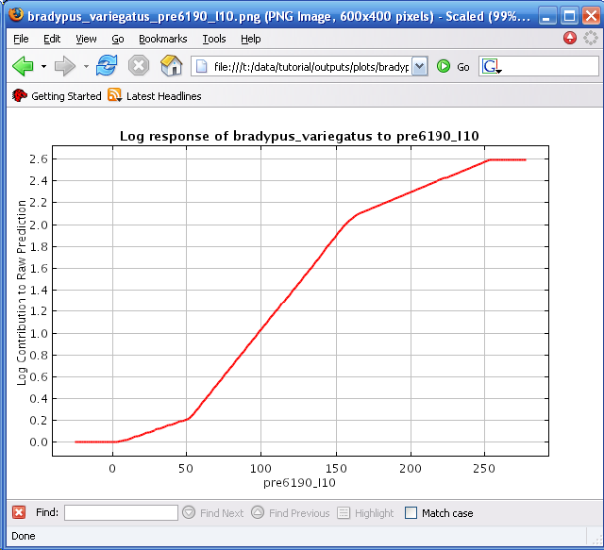

The outline of the two profiles is similar, but they differ because the different classes of feature types are limited in the shapes of response curves they are capable of modeling. Using all classes together (the default, given enough samples) allows many complex response curves to be accurately modeled.

SWD Format

There is a second input format that can be very useful, especially when your environmental grids are very large. For lack of a better name, it’s called “samples with data”, or just SWD. The SWD version of our Bradypus file, called “bradypus_swd.csv”, starts like this:

species,longitude,latitude,cld6190_ann,dtr6190_ann,ecoreg,frs6190_ann,h_dem,pre6190_ann,pre6190_l10,pre6190_l1,pre6190_l4,pre6190_l7,tmn6190_ann,tmp6190_ann,tmx6190_ann,vap6190_ann
bradypus_variegatus,-65.4,-10.3833,76.0,104.0,10.0,2.0,121.0,46.0,41.0,84.0,54.0,3.0,192.0,266.0,337.0,279.0
bradypus_variegatus,-65.3833,-10.3833,76.0,104.0,10.0,2.0,121.0,46.0,40.0,84.0,54.0,3.0,192.0,266.0,337.0,279.0
bradypus_variegatus,-65.1333,-16.8,57.0,114.0,10.0,1.0,211.0,65.0,56.0,129.0,58.0,34.0,140.0,244.0,321.0,221.0
bradypus_variegatus,-63.6667,-17.45,57.0,112.0,10.0,3.0,363.0,36.0,33.0,71.0,27.0,13.0,135.0,229.0,307.0,202.0
bradypus_variegatus,-63.85,-17.4,57.0,113.0,10.0,3.0,303.0,39.0,35.0,77.0,29.0,15.0,134.0,229.0,306.0,202.0

It can be used in place of an ordinary samples file. The difference is only that the program doesn’t need to look in the environmental layers to get values for the variables at the sample points. The environmental layers are thus only used to get “background” pixels – pixels where the species hasn’t necessarily been found. In fact, the background pixels can also be specified in a SWD format file, in which case the “species” column is ignored. The file “background.csv” has 10,000 background data points in it. The first few look like this:

background,-61.775,6.175,60.0,100.0,10.0,0.0,747.0,55.0,24.0,57.0,45.0,81.0,182.0,239.0,300.0,232.0
background,-66.075,5.325,67.0,116.0,10.0,3.0,1038.0,75.0,16.0,68.0,64.0,145.0,181.0,246.0,331.0,234.0
background,-59.875,-26.325,47.0,129.0,9.0,1.0,73.0,31.0,43.0,32.0,43.0,10.0,97.0,218.0,339.0,189.0
background,-68.375,-15.375,58.0,112.0,10.0,44.0,2039.0,33.0,67.0,31.0,30.0,6.0,101.0,181.0,251.0,133.0
background,-68.525,4.775,72.0,95.0,10.0,0.0,65.0,72.0,16.0,65.0,69.0,133.0,218.0,271.0,346.0,289.0

We can run Maxent with “bradypus_swd.csv” as the samples file and “background.csv” (both located in the “swd” directory) as the environmental layers file. Try running it – you’ll notice that it runs much faster, because it doesn’t have to load the big environmental grids. The downside is that it can’t make pictures or output grids, because it doesn’t have all the environmental data. The way to get around this is to use a “projection”, described below.

Batch running

Sometimes you need to generate a number of models, perhaps with slight variations in the modeling parameters or the inputs. This can be automated using command-line arguments, avoiding the repetition of having to click and type at the program interface. The command line arguments can either be given from a command window (a.k.a. shell), or they can defined in a batch file. Take a look at the file “batchExample.bat” (for example, using Notepad). It contains the following line:

java -mx512m -jar maxent.jar environmentallayers=layers togglelayertype=ecoreg samplesfile=samples\bradypus.csv outputdirectory=outputs redoifexists autorun

The effect is to tell the program where to find environmental layers and samples file and where to put outputs, to indicate that the ecoreg variable is categorical. The “autorun” flag tells the program to start running immediately, without waiting for the “Run” button to be pushed. Now try clicking on the file, to see what it does.

Many aspects of the Maxent program can be controlled by command-line arguments – press the “Help” button to see all the possibilities. Multiple runs can appear in the same file, and they will simply be run one after the other. You can change the default values of most parameters by adding command-line arguments to the “maxent.bat” file.

Regularization.

The “regularization multiplier” parameter on the “settings” panel affects how focused the output distribution is – a smaller value will result in a more localized output distribution that fits the given presence records better, but is more prone to overfitting. A larger value will give a more spread-out prediction. Try changing the multiplier, and look at the pictures produced. As an example, setting the multiplier to 3 makes the following picture, showing a much more diffuse distribution than before:

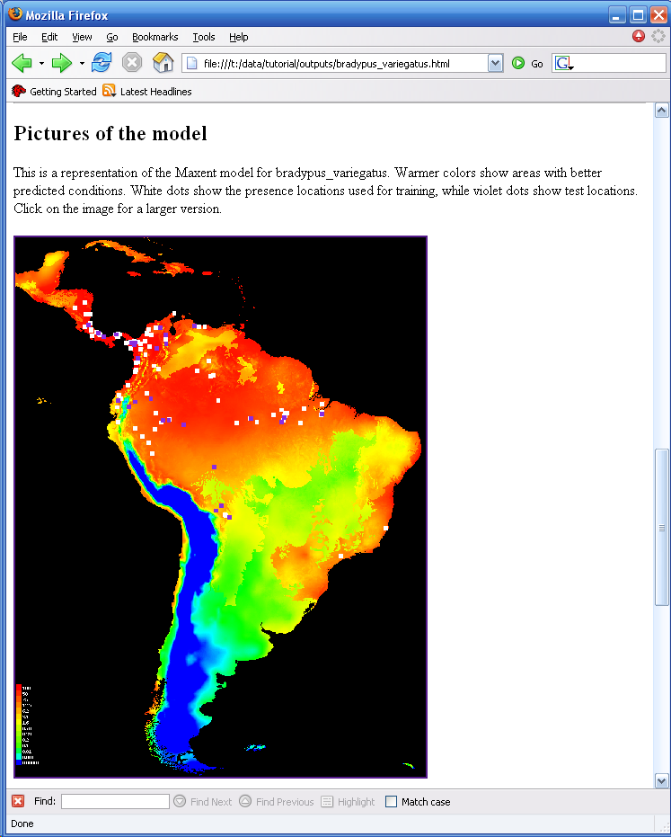
Projecting

A model trained on one set of environmental layers can be “projected” by applying it to another set of environmental layers. Situations where projections are needed include modeling species distributions under changing climate conditions, and modeling invasive species. Here we’re going to use projection for a very simple task: making an output grid and associated picture when the samples and background are in SWD format. Type or browse in the samples file entry to point to the file “swd\bradypus_swd.csv”, and similarly for the environmental layers in “swd\background.csv”, then enter the “layers” directory in the “Projection Layers Directory”, as pictured below.

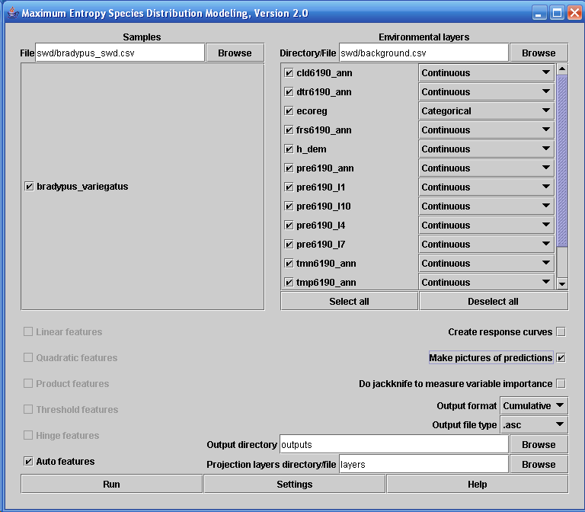

When you press “Run”, a model is trained on the SWD data, and then projected onto the full grids in the “layers” directory. The output grid is called “bradypus_variegatus_layers.asc”, and in general, the projection directory name is appended to the species name, in order to distinguish it from the standard (un-projected) output. If “make pictures of predictions” is selected, a picture of the projected model will appear in the “bradypus.html” file.

